[](http://www.joynb.net/blog/wp-content/uploads/2011/04/PPT1.png)

这是我2005-2007年在公司培训时候的讲义，当时现场效果相当热烈：

可以到下面地址下载：

课程用例下载：<http://www.joynb.net/blog/archives/83>

[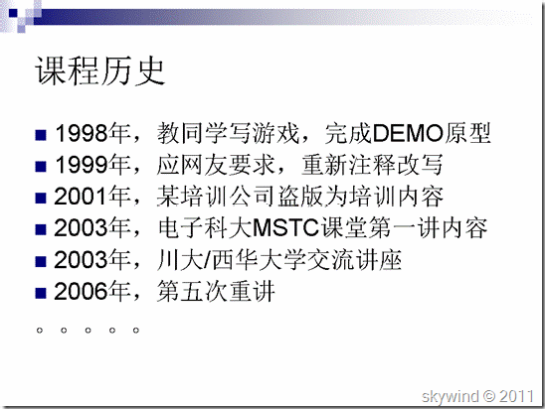](http://hi.csdn.net/attachment/201104/23/0_1303537212Yae7.gif)  
[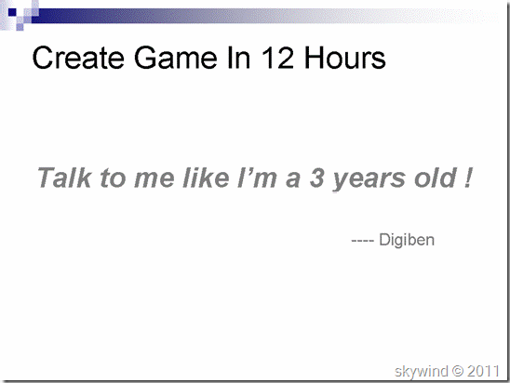](http://hi.csdn.net/attachment/201104/23/0_1303537213F1px.gif)  
[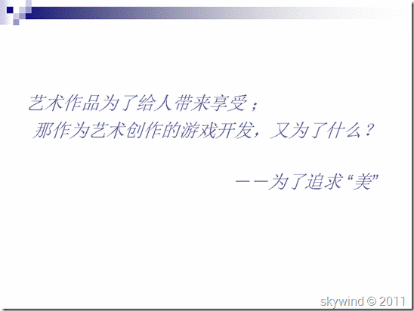](http://hi.csdn.net/attachment/201104/23/0_13035372156DW6.gif)  
[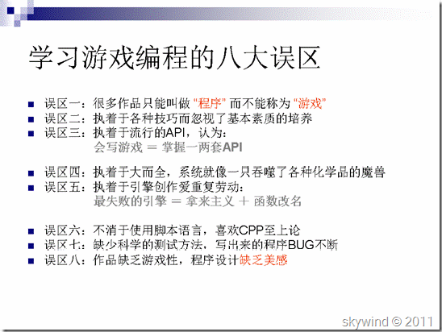](http://hi.csdn.net/attachment/201104/23/0_1303537216rRwa.gif)  
[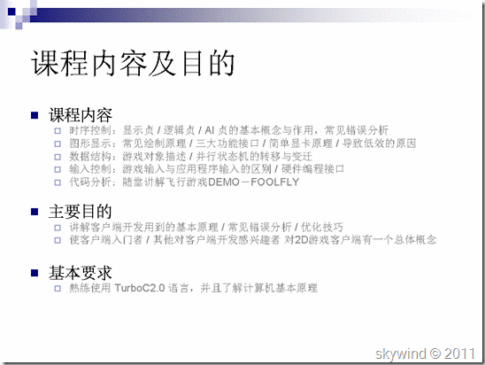](http://hi.csdn.net/attachment/201104/23/0_1303537218aWn5.gif)  
[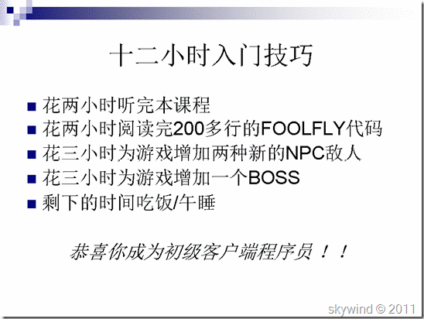](http://hi.csdn.net/attachment/201104/23/0_1303537220wISs.gif)  
[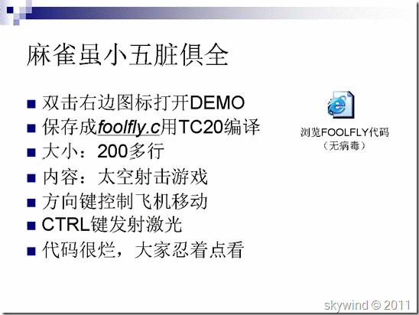](http://hi.csdn.net/attachment/201104/23/0_1303537222BR5P.gif)  
[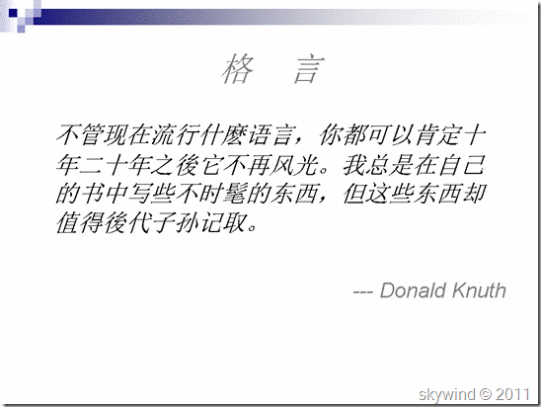](http://hi.csdn.net/attachment/201104/23/0_1303537224iQL9.gif)  
[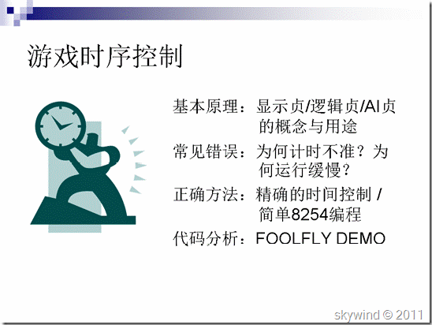](http://hi.csdn.net/attachment/201104/23/0_13035372259WOt.gif)  
[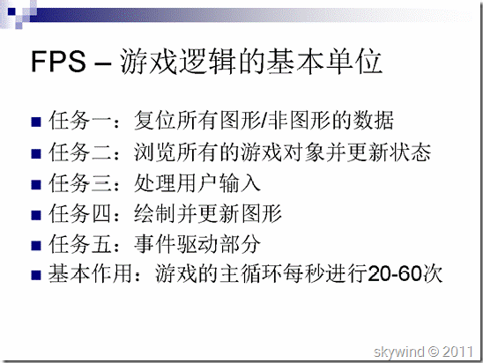](http://hi.csdn.net/attachment/201104/23/0_1303537227Ss82.gif)  
[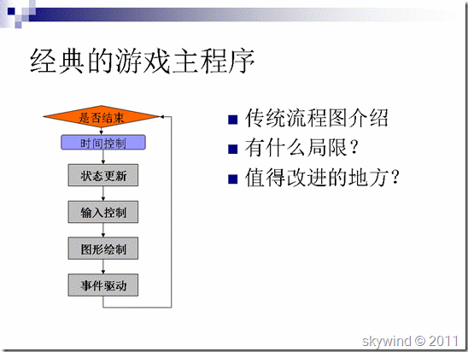](http://hi.csdn.net/attachment/201104/23/0_1303537229uu62.gif)  
[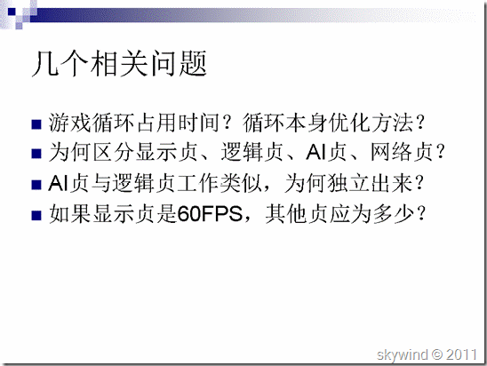](http://hi.csdn.net/attachment/201104/23/0_1303537231E6j9.gif)  
[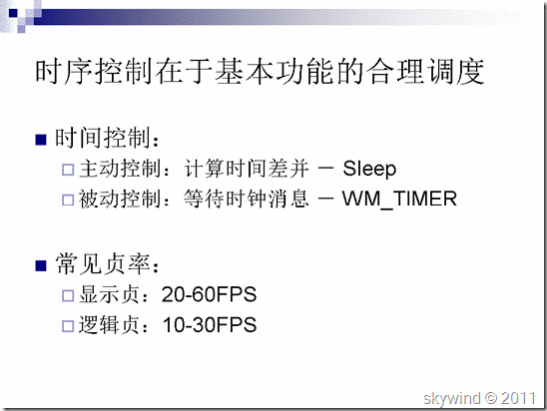](http://hi.csdn.net/attachment/201104/23/0_1303537232w0n4.gif)  
[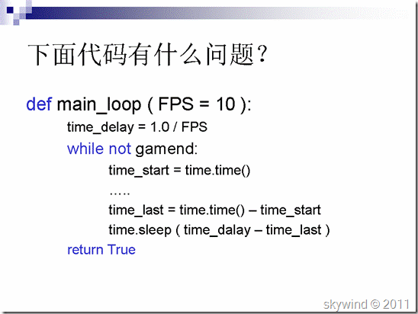](http://hi.csdn.net/attachment/201104/23/0_1303537234Pjk2.gif)  
[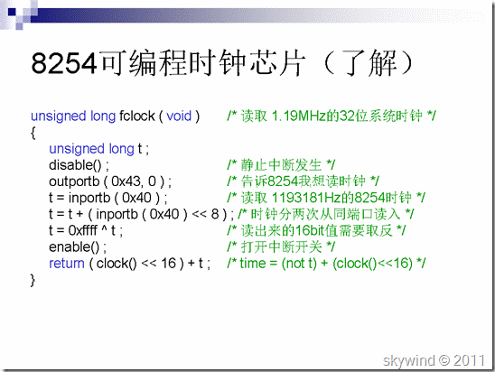](http://hi.csdn.net/attachment/201104/23/0_13035372367iUI.gif)  
[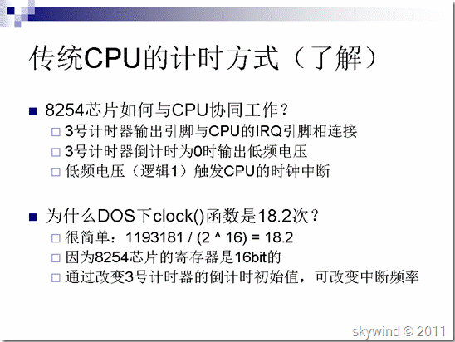](http://hi.csdn.net/attachment/201104/23/0_1303537237kw7q.gif)  
[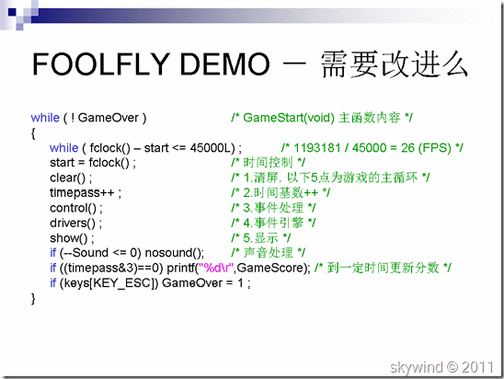](http://hi.csdn.net/attachment/201104/23/0_1303537239Nb25.gif)  
[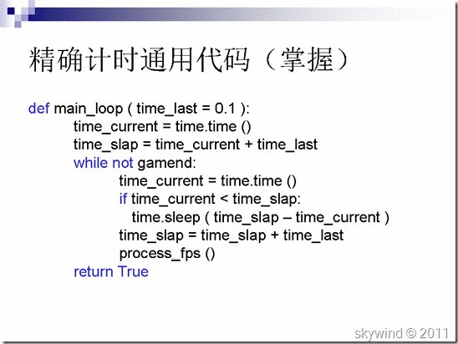](http://hi.csdn.net/attachment/201104/23/0_1303537241hKt8.gif)  
[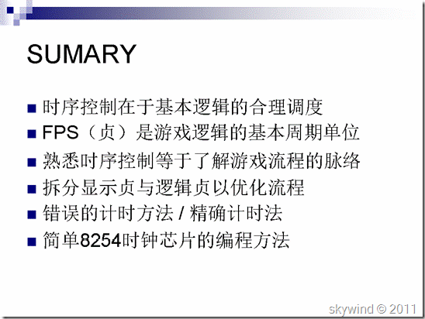](http://hi.csdn.net/attachment/201104/23/0_13035372432oOk.gif)  
[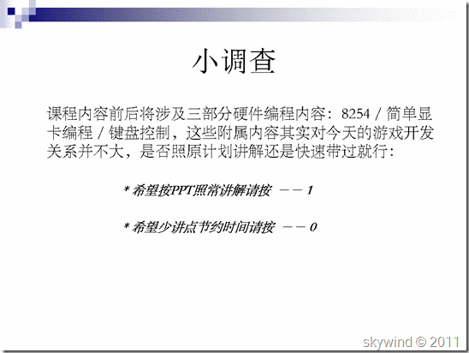](http://hi.csdn.net/attachment/201104/23/0_1303537245FZ9k.gif)  
[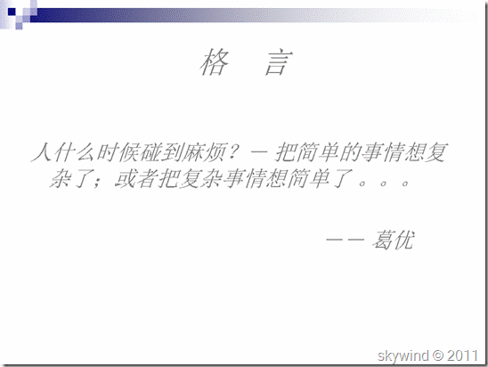](http://hi.csdn.net/attachment/201104/23/0_13035372468TG8.gif)  
[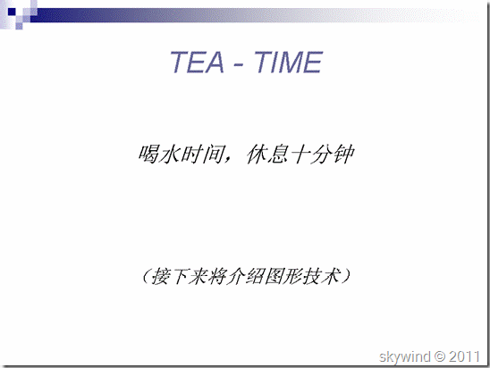](http://hi.csdn.net/attachment/201104/23/0_1303537248C2WP.gif)  
[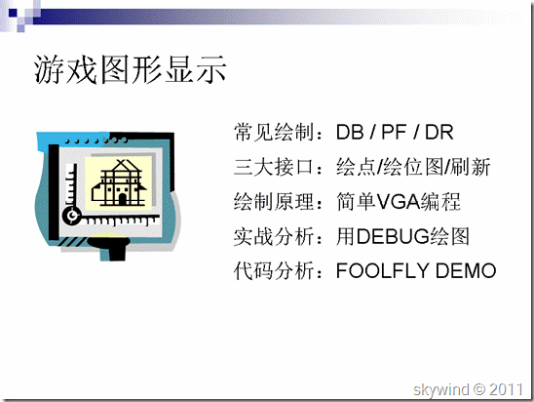](http://hi.csdn.net/attachment/201104/23/0_1303537249KK8c.gif)  
[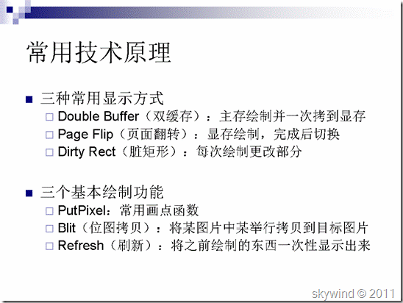](http://hi.csdn.net/attachment/201104/23/0_1303537251Qgd1.gif)  
[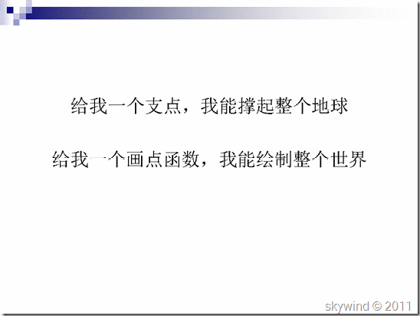](http://hi.csdn.net/attachment/201104/23/0_1303537252p1p0.gif)  
[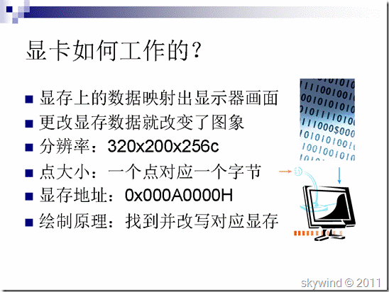](http://hi.csdn.net/attachment/201104/23/0_1303537254UqIq.gif)  
[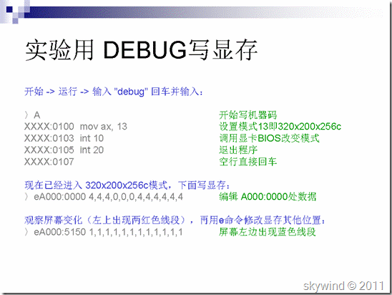](http://hi.csdn.net/attachment/201104/23/0_1303537256P8NM.gif)  
[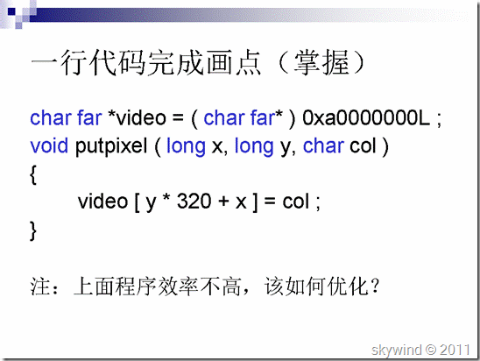](http://hi.csdn.net/attachment/201104/23/0_13035372582mr2.gif)  
[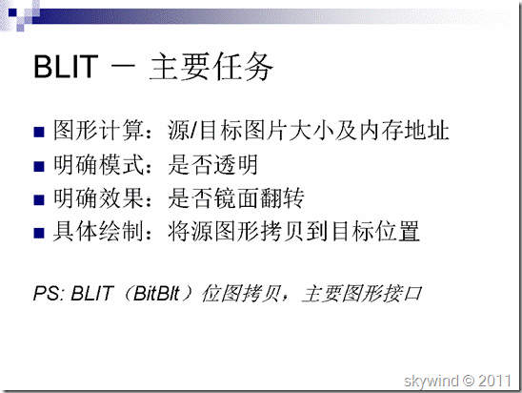](http://hi.csdn.net/attachment/201104/23/0_1303537259WX5C.gif)  
[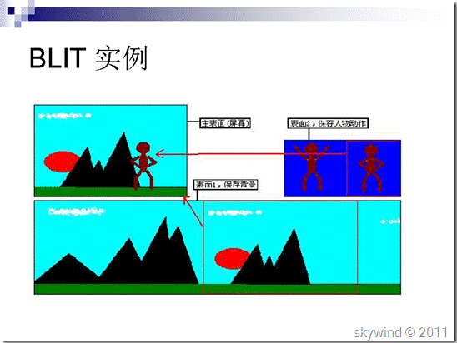](http://hi.csdn.net/attachment/201104/23/0_130353726163Dp.gif)  
[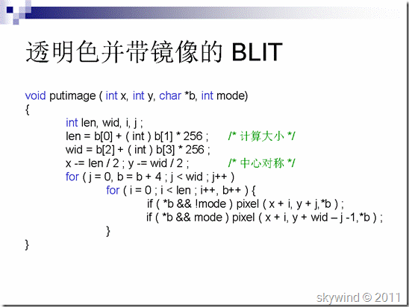](http://hi.csdn.net/attachment/201104/23/0_13035372639RcE.gif)  
[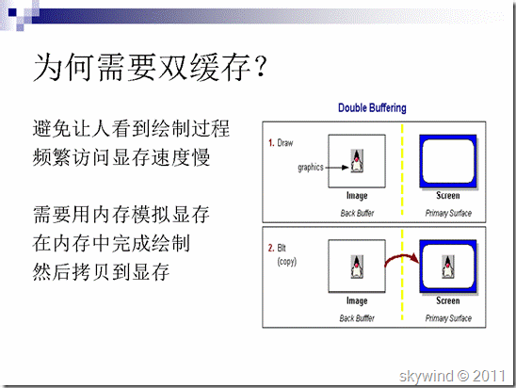](http://hi.csdn.net/attachment/201104/23/0_1303537265mUaB.gif)  
[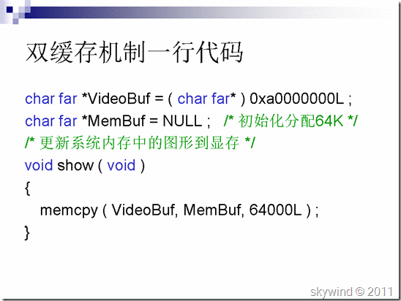](http://hi.csdn.net/attachment/201104/23/0_13035372675klY.gif)  
[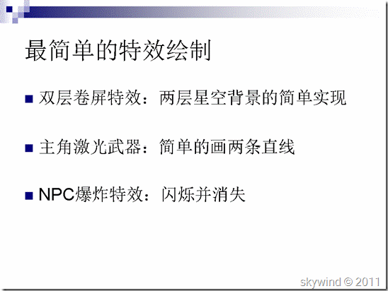](http://hi.csdn.net/attachment/201104/23/0_1303537268MzD8.gif)  
[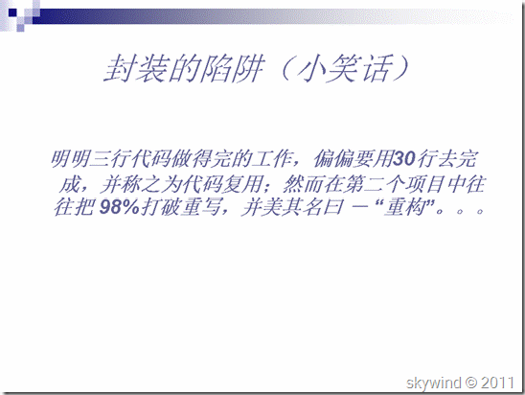](http://hi.csdn.net/attachment/201104/23/0_1303537270B7EB.gif)  
[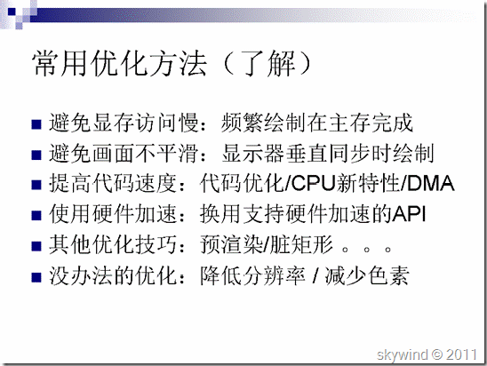](http://hi.csdn.net/attachment/201104/23/0_1303537271wL51.gif)  
[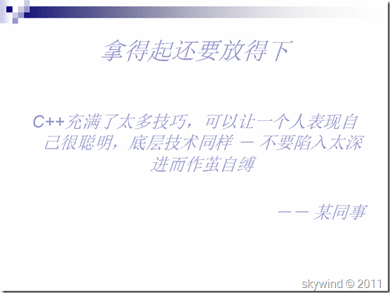](http://hi.csdn.net/attachment/201104/23/0_13035372733C1C.gif)  
[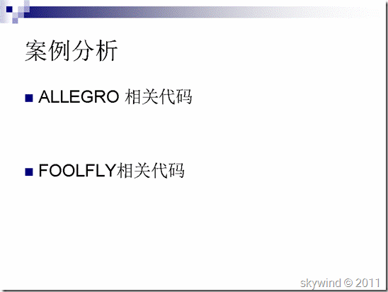](http://hi.csdn.net/attachment/201104/23/0_13035372755E8I.gif)  
[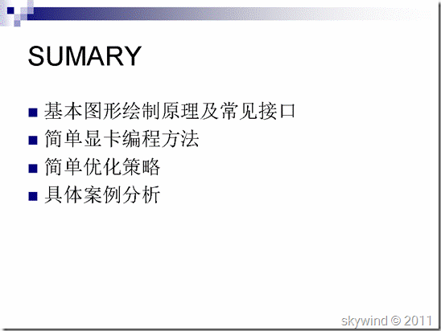](http://hi.csdn.net/attachment/201104/23/0_1303537276PJoN.gif)  
[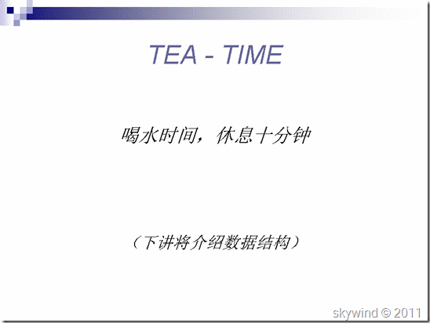](http://hi.csdn.net/attachment/201104/23/0_13035372779Izd.gif)  
[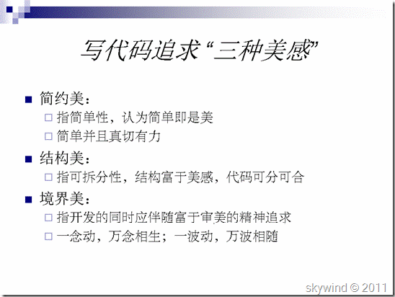](http://hi.csdn.net/attachment/201104/23/0_13035372789qSc.gif)  
[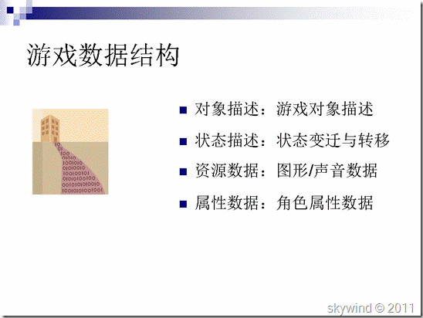](http://hi.csdn.net/attachment/201104/23/0_1303537280tGe9.gif)  
[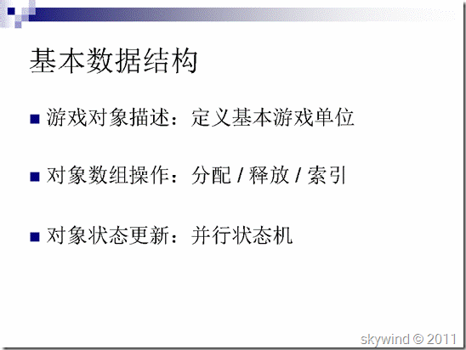](http://hi.csdn.net/attachment/201104/23/0_1303537282F0qQ.gif)  
[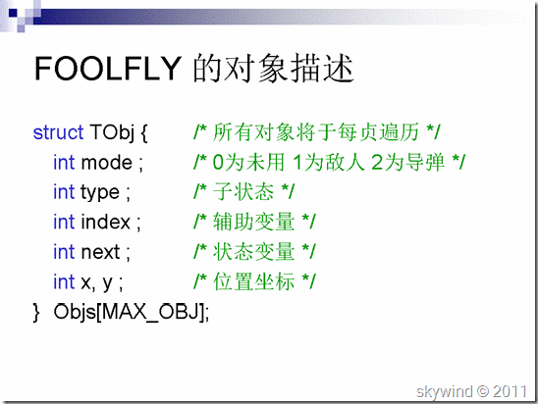](http://hi.csdn.net/attachment/201104/23/0_1303537283VL0Q.gif)  
[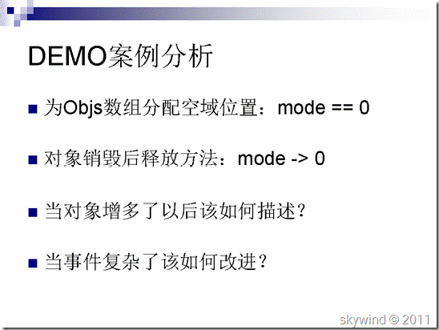](http://hi.csdn.net/attachment/201104/23/0_1303537285ttIt.gif)  
[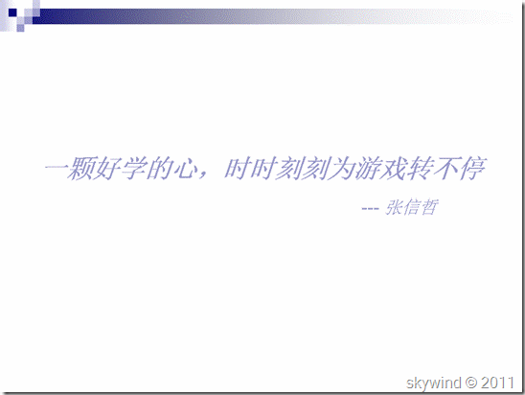](http://hi.csdn.net/attachment/201104/23/0_1303537286bsGw.gif)  
[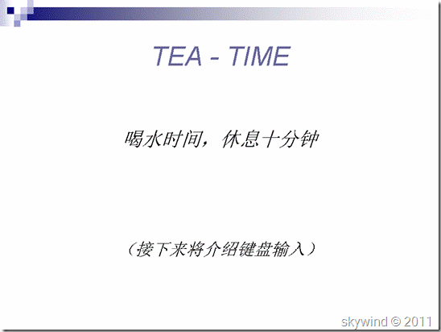](http://hi.csdn.net/attachment/201104/23/0_1303537287cij2.gif)  
[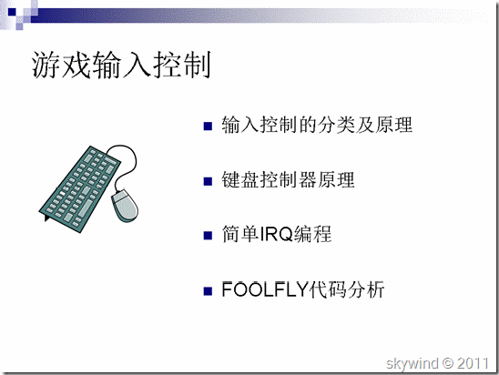](http://hi.csdn.net/attachment/201104/23/0_1303537289Ozwl.gif)  
[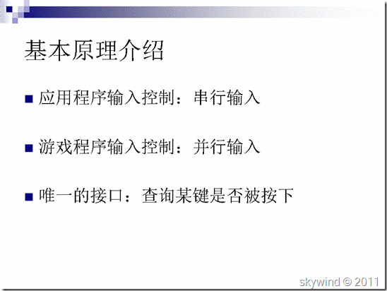](http://hi.csdn.net/attachment/201104/23/0_1303537290SS7x.gif)  
[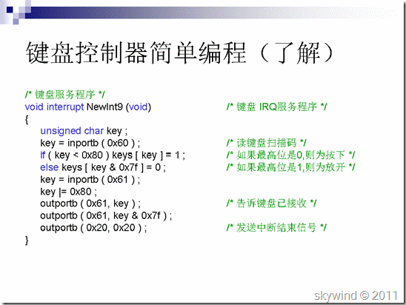](http://hi.csdn.net/attachment/201104/23/0_1303537292MXMM.gif)  
[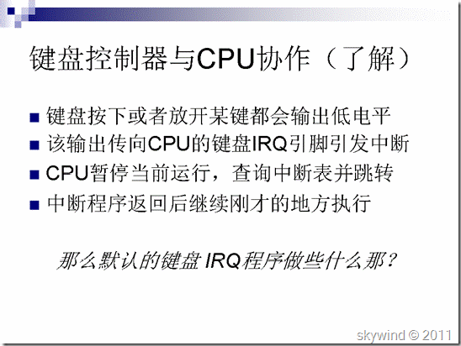](http://hi.csdn.net/attachment/201104/23/0_1303537294JE0j.gif)  
[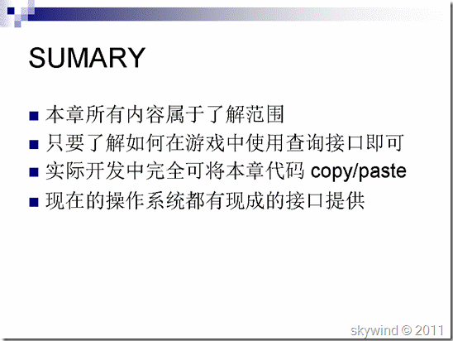](http://hi.csdn.net/attachment/201104/23/0_1303537296730q.gif)  
[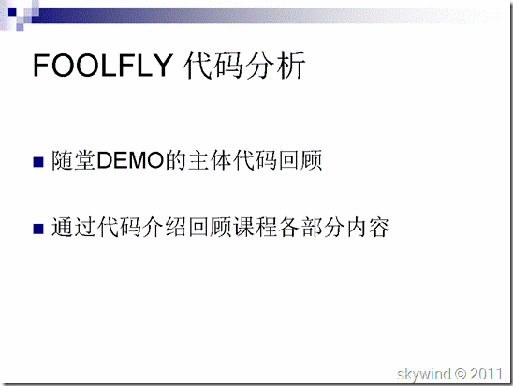](http://hi.csdn.net/attachment/201104/23/0_13035372972DY8.gif)  
[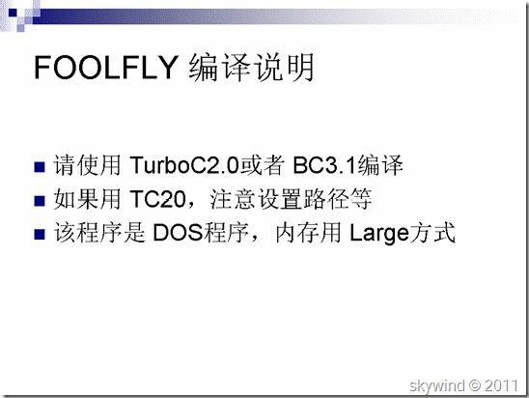](http://hi.csdn.net/attachment/201104/23/0_1303537298J3IR.gif)  
[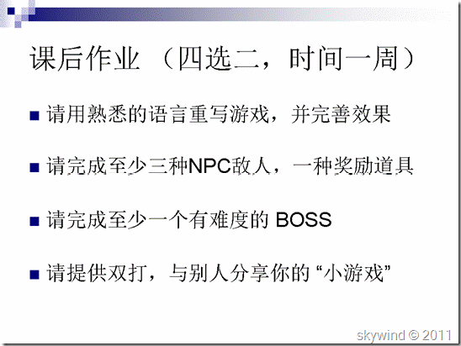](http://hi.csdn.net/attachment/201104/23/0_1303537300l2j2.gif)